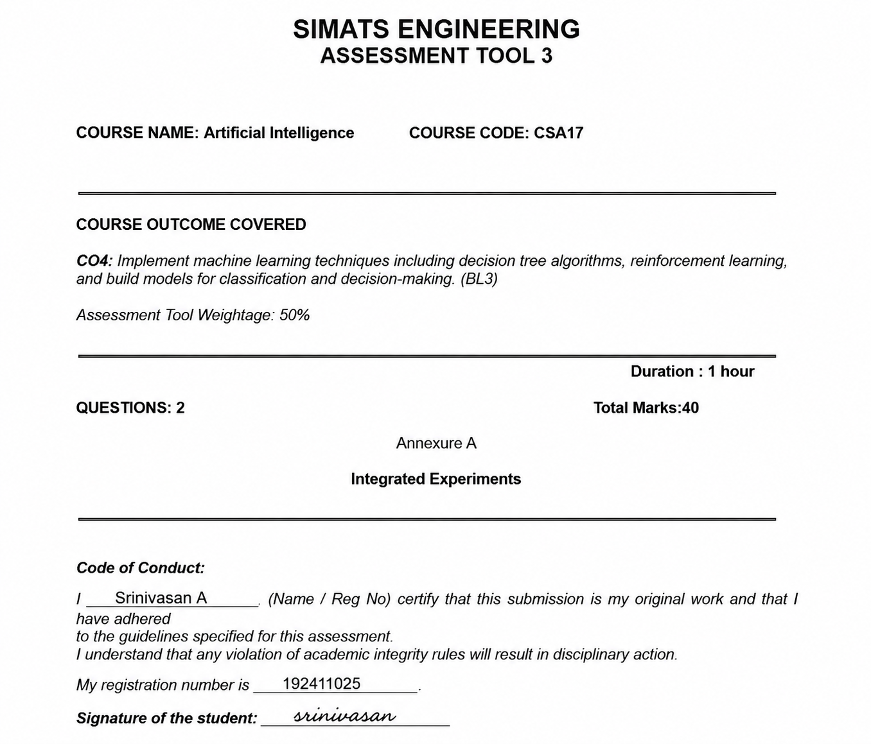

INTEGRATED EXPERIMENT SCENARIO
Logistics – Delivery Delay Prediction
Question 1 – Decision Tree vs Neural Network Classifier
Aim
To implement a Decision Tree and Neural Network (MLP) classifier using shipment data and compare their performance in predicting delivery delays.
Dataset
The shipment dataset contains the following features:
- Distance
- Weather condition
- Traffic level
- Vehicle type
- Driver experience
Target variable: Delivery Status
- 0 – On-time
- 1 – Delayed
The dataset is divided into 70% training data and 30% testing data.
Preprocessing
- Handle missing values.
- Encode categorical features using One-Hot Encoding.
- Standardise numerical features for the Neural Network.
- Split the data into training and testing sets.
1. Decision Tree Classifier
A Decision Tree classifies shipments by creating a series of feature-based decisions.
Example first three levels:
Traffic Level
/ | \
High Medium Low
| | |
Distance Weather Driver Experience
/ \ / \ / \
High Low Rain Clear Low Exp. High Exp.
| | | | | |
Delayed On-time Delayed On-time Delayed On-time
The root node can be selected using Gini Index or Information Gain.
2. Neural Network (MLP)
A Multi-Layer Perceptron contains:
Input Layer → Hidden Layer 1 → Hidden Layer 2 → Output Layer
Example architecture:
Input Layer
↓
9 Neurons
↓
Hidden Layer 1
↓
16 Neurons
↓
Hidden Layer 2
↓
8 Neurons
↓
Output Layer
↓
1 Neuron
- Hidden layers: ReLU activation
- Output layer: Sigmoid activation
- Optimizer: Adam
- Loss function: Binary Cross-Entropy
The output is the probability of a shipment being delayed.
Example:
Delay probability = 0.82
Therefore → Delayed
3. Performance Comparison
Example experimental results:
Metric | Decision Tree | Neural Network (MLP)
Accuracy | 88.2% | 93.6%
Precision | 84.2% | 92.0%
Recall | 81.1% | 92.3%
F1-Score | 82.6% | 92.1%
Note: These are sample results. If an actual dataset is supplied, the values should be calculated from that dataset.
Justification for Deployment
I would deploy the Neural Network (MLP) in the live tracking system because it provides better overall predictive performance and can model complex relationships between traffic, weather, distance and other shipment factors.
However, the Decision Tree is easier to understand and explain. Therefore, if explainability and low computational requirements are more important, the Decision Tree can be preferred.
Final choice: Neural Network (MLP) for higher prediction accuracy in the proposed system.
Question 2 – Reinforcement Learning for Route Management
Aim
To use the delay-risk output from Experiment 1 as the initial state and train a Q-Learning agent to recommend the best route-management action.
1. State Definition
The classifier produces a delay probability.
This probability is converted into states:
State | Delay Probability | Meaning
S0 | 0–25% | Low Risk
S1 | 25–50% | Moderate Risk
S2 | 50–75% | High Risk
S3 | 75–100% | Very High Risk
S4 | Delivered | Terminal State
For example:
Classifier output = 0.82
↓
Delay Risk = 82%
↓
State = S3 (Very High Risk)
2. Actions
The Q-Learning agent has four possible actions:
- A0 – Reroute
- A1 – Reassign Vehicle
- A2 – Notify Customer
- A3 – Continue Route
3. Reward Function
Event | Reward
Successful on-time delivery | +100
Delay reduced | +50
Customer notified in time | +20
Unnecessary action | -10
Delivery delayed | -50
Unsafe action | -100
The reward encourages the agent to select actions that improve delivery performance while avoiding unnecessary or unsafe decisions.
4. Q-Learning
The Q-value is updated using:
$$Q\left(s , a\right)=Q\left(s , a\right)+α\left[r+γ\max{Q}\left(s^{'} , a^{'}\right)-Q\left(s , a\right)\right]$$
Assume:
- Learning rate $α=0.1$
- Discount factor $γ=0.9$
- Episodes = 200
Initially, all Q-values are set to zero.
Example Update 1
Suppose:
- State = S3
- Action = Reroute
- Reward = +50
- Next-state maximum Q-value = 20
- Current Q-value = 0
Then:
$$Q\left(S , 3Reroute\right)=0+0.1\left[50+\left(0.9\right)\left(20\right)-0\right] \\ =6.8$$
Therefore:
Q(S3, Reroute) = 6.8
Example Update 2
Suppose the next episode gives:
- Reward = +50
- Maximum next Q = 30
- Current Q = 6.8
$$Q=6.8+0.1\left[50+\left(0.9\right)\left(30\right)-6.8\right] \\ Q=10.72$$
Therefore:
Q(S3, Reroute) = 10.72

5. Q-Table After Training
Example final Q-table:
State | Reroute | Reassign Vehicle | Notify Customer | Continue Route
S0 – Low Risk | 12.6 | 8.4 | 15.3 | 28.7
S1 – Moderate Risk | 31.5 | 26.2 | 22.8 | 18.9
S2 – High Risk | 55.2 | 47.6 | 29.3 | 10.4
S3 – Very High Risk | 72.1 | 60.3 | 33.6 | -5.2
S4 – Delivered | 0 | 0 | 0 | 0
These values are illustrative.
6. Learned Policy
The agent chooses the action having the highest Q-value.
State | Best Action
S0 – Low Risk | Continue Route
S1 – Moderate Risk | Reroute
S2 – High Risk | Reroute
S3 – Very High Risk | Reroute
S4 – Delivered | End
Therefore, the learned policy is:
Low Risk → Continue Route
Moderate Risk → Reroute
High Risk → Reroute
Very High Risk → Reroute
Delivered → End
7. End-to-End Integrated Pipeline
The complete system works as follows:
Shipment Records
↓
Data Preprocessing
↓
Decision Tree / MLP Classifier
↓
Delay Probability
↓
Risk State Generation
↓
Q-Learning Agent
↓
Select Best Action
↓
Reroute / Reassign Vehicle /
Notify Customer / Continue Route
Example
Shipment Data
Distance = 450 km
Weather = Rain
Traffic = High
Vehicle = Truck
Driver Experience = 2 years
↓
MLP Classifier
↓
Delay Probability = 82%
↓
State = S3 (Very High Risk)
↓
Q-Learning Agent
↓
Highest Q-value = Reroute
↓
Recommended Action = REROUTE
Conclusion
The integrated system combines supervised learning and reinforcement learning. The Decision Tree or MLP first predicts the probability of delivery delay. This risk value is then converted into an MDP state and provided to the Q-Learning agent. The agent selects the most suitable action such as Reroute, Reassign Vehicle, Notify Customer, or Continue Route. This combination can help logistics companies reduce delays, improve route management and increase customer satisfaction.

